|  |  |  |  |  |  |
| --- | --- | --- | --- | --- | --- |
| Date | 7-Sep-22 | | | Tester Name | Mohammad Yusuf |
| Environment | Penfax - Test | | | Login used |  |
| Operating System | Select OS | Version: | Update: | | |
| Software Used | Select Software | Version: | Update: | | |
| Select Software | Version: | Update: | | |
| Release version |  | | | | |
| Title | M17 Contributions & DCT | | | | |
| Test Type | Regression | | | | |
| Test Scenario | M17.11 Creating a Termination File | | | | |
|  |  | | | | |
| Expected Results | Employment should be ended with the effective date.  Member Status should be Pending. | | | | |
| Pass/Fail | Pass | | | JIRA# | N/A |

Describe your steps with screenshots:

1. Bring up an active MEPP member.

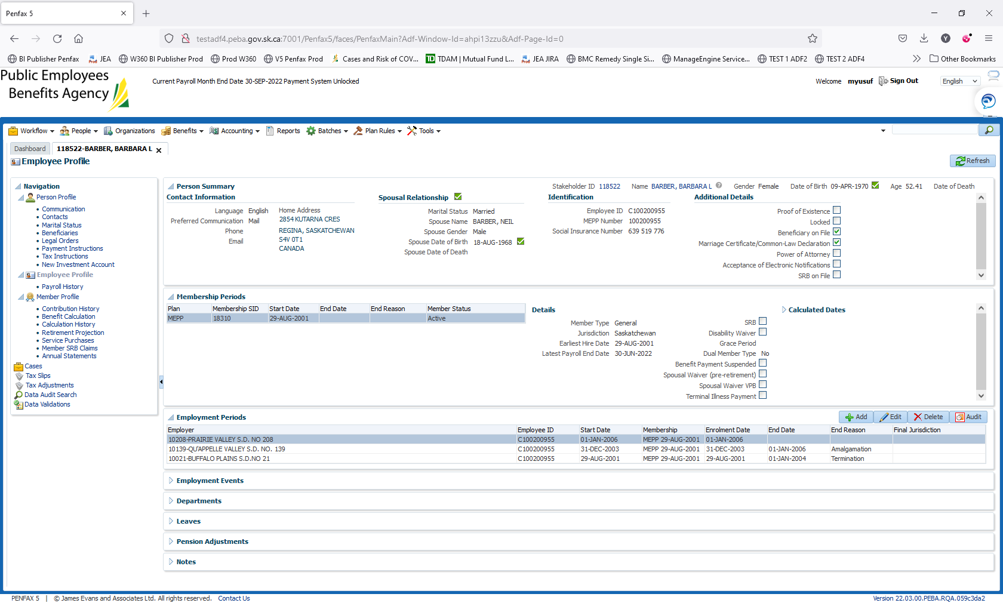

1. Log into MEPP DCT and select the Employer from the dropdown. Click on Create New File.



1. Select Termination from the dropdown and click Create.

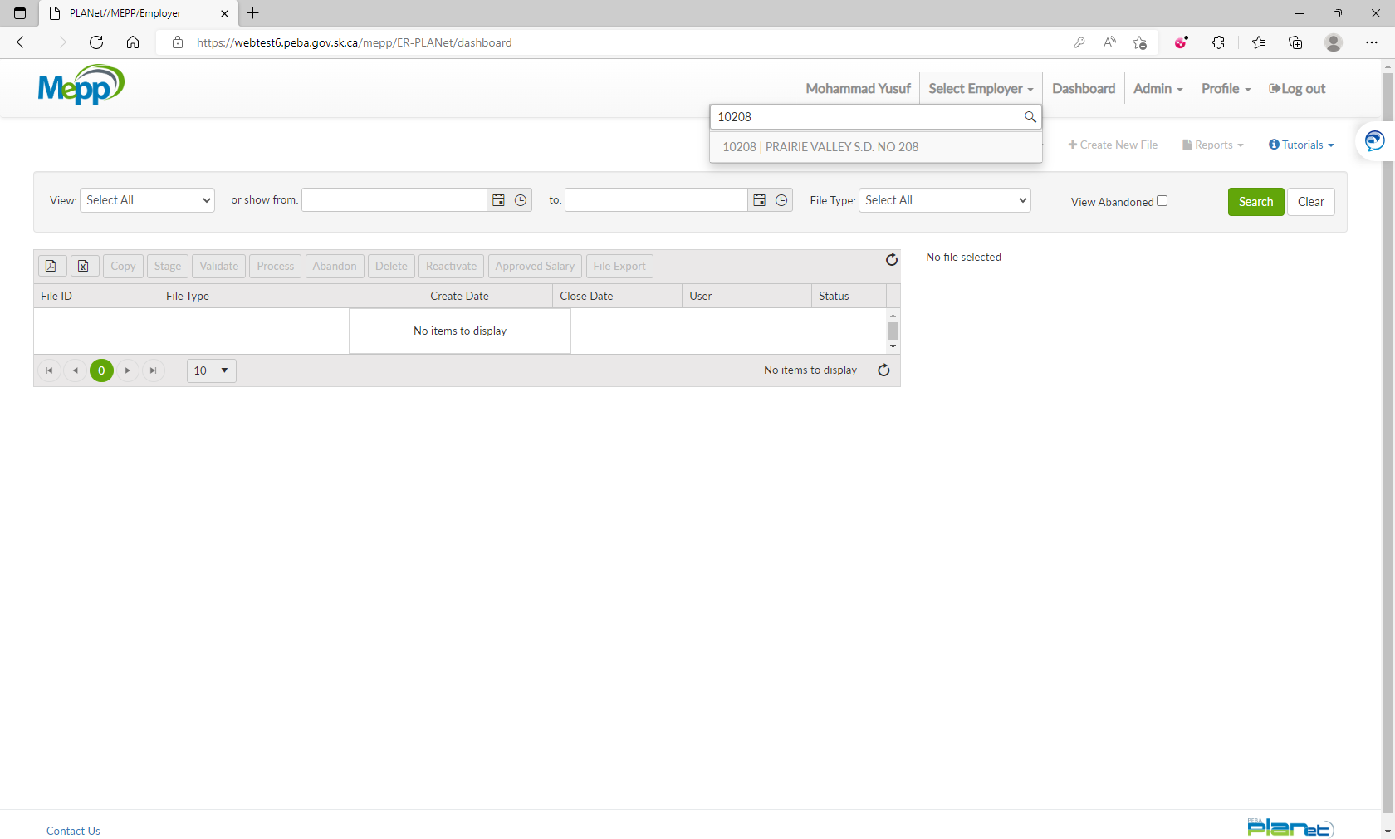

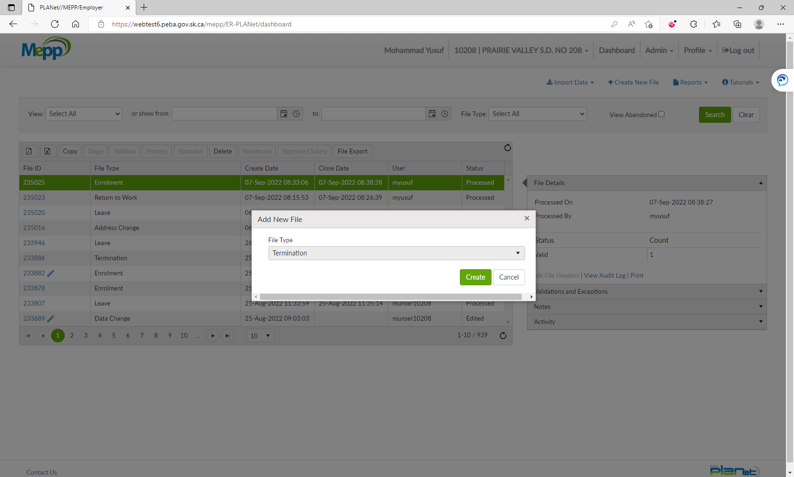

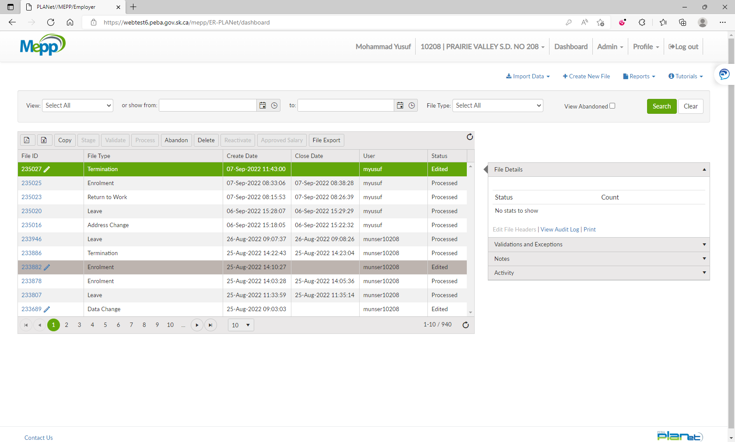

1. Click on File ID to add the transactions.

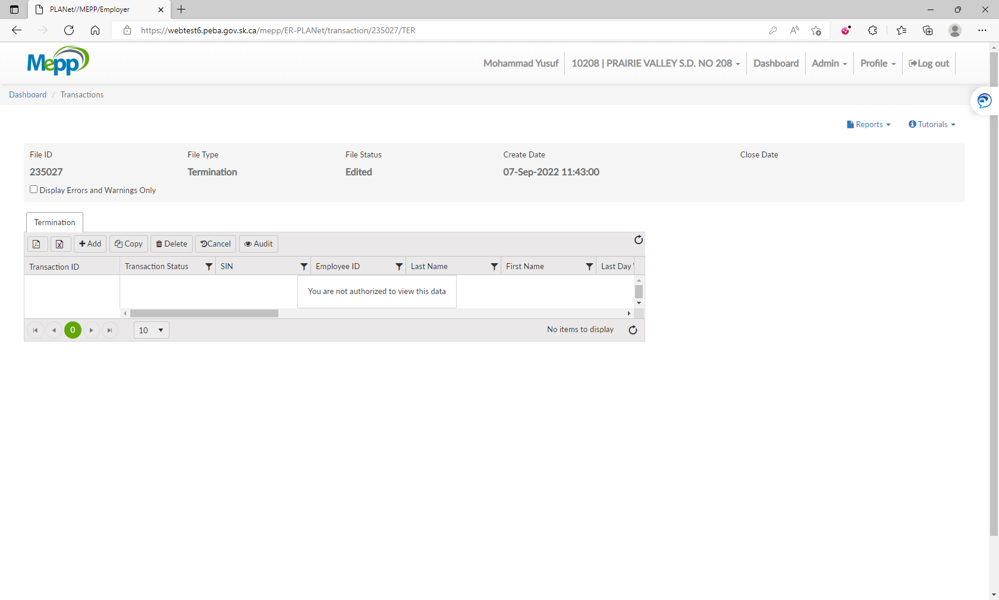

1. Input required details and click Save.

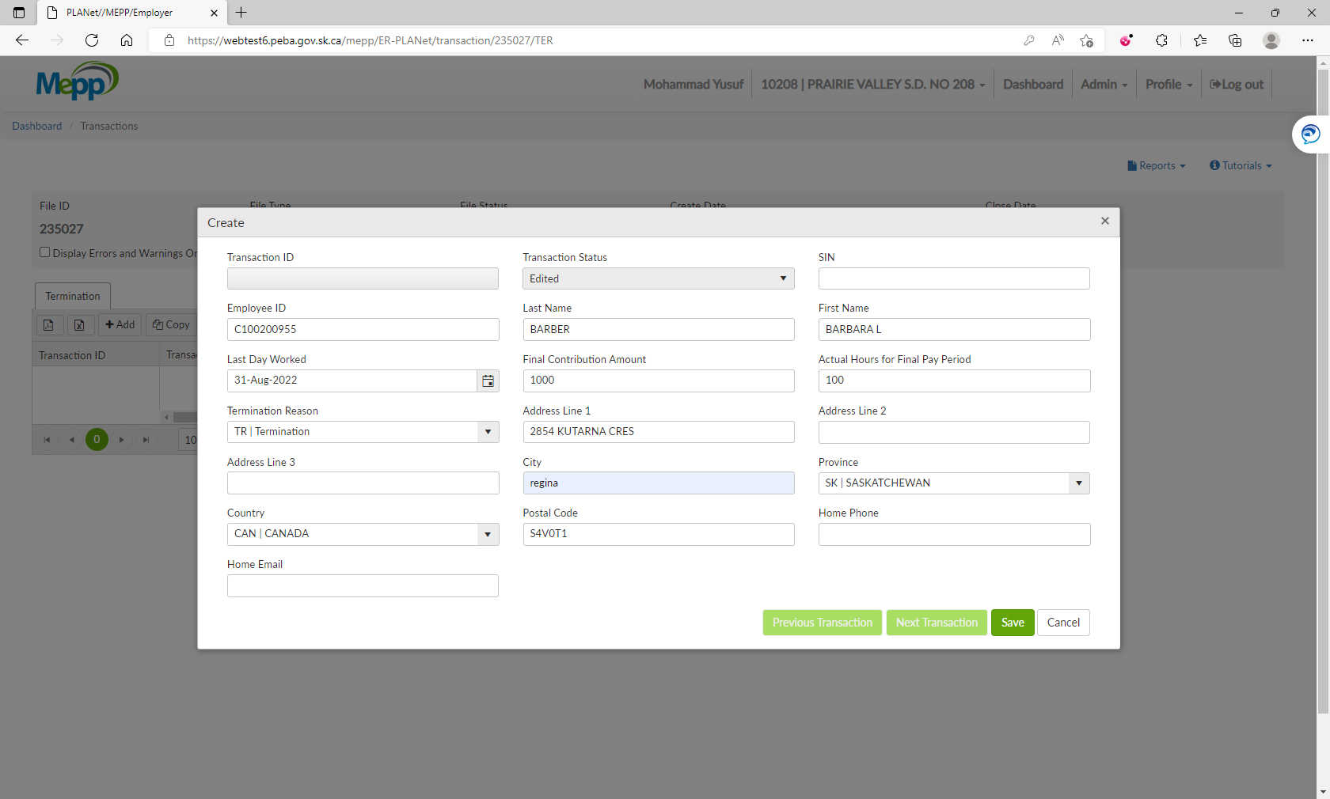

1. Under File Details, click on Validate and then Process.

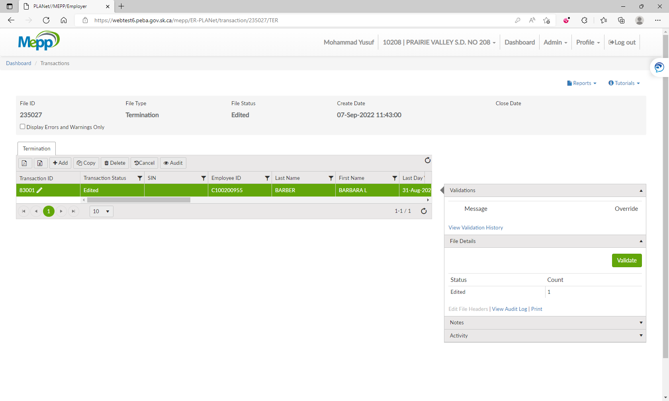

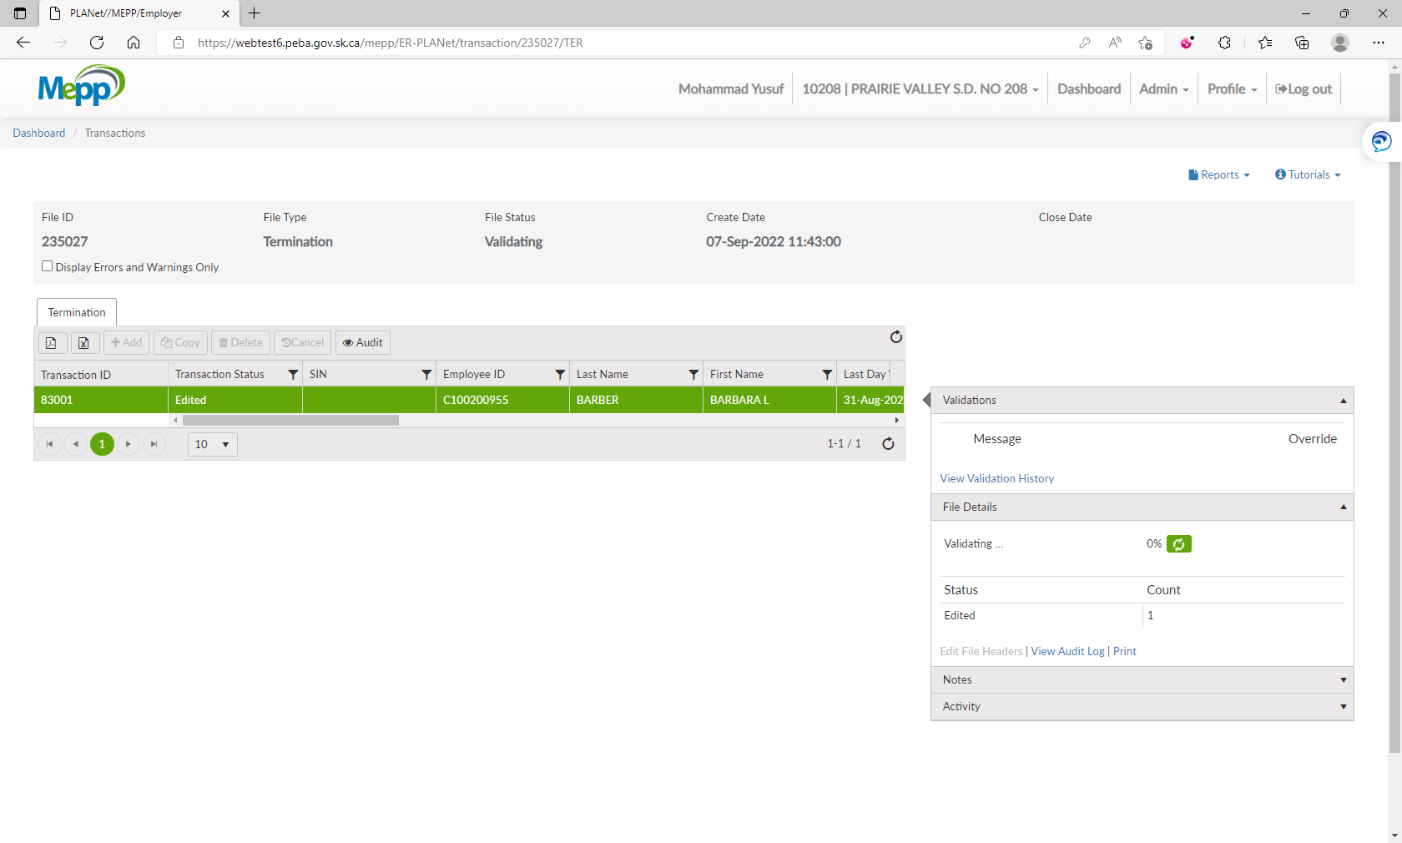

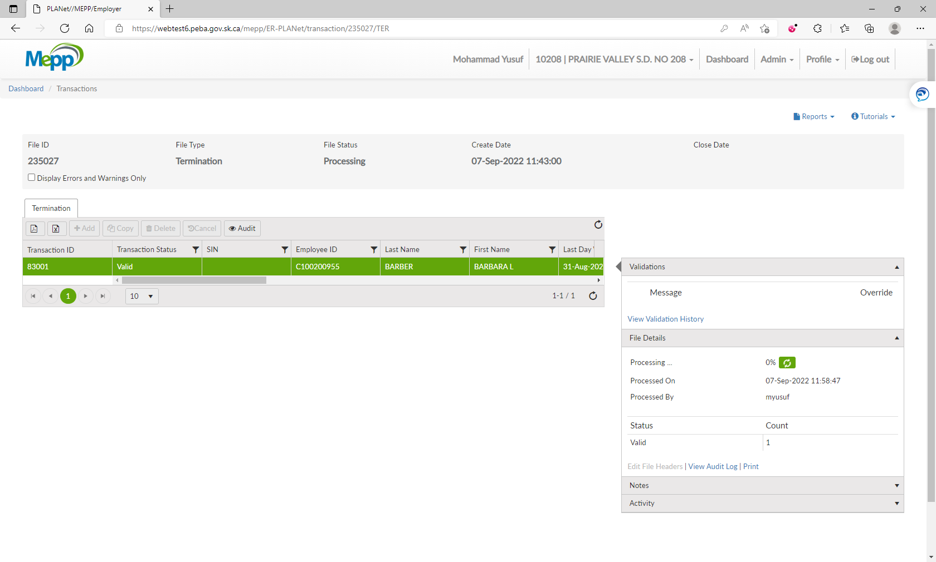

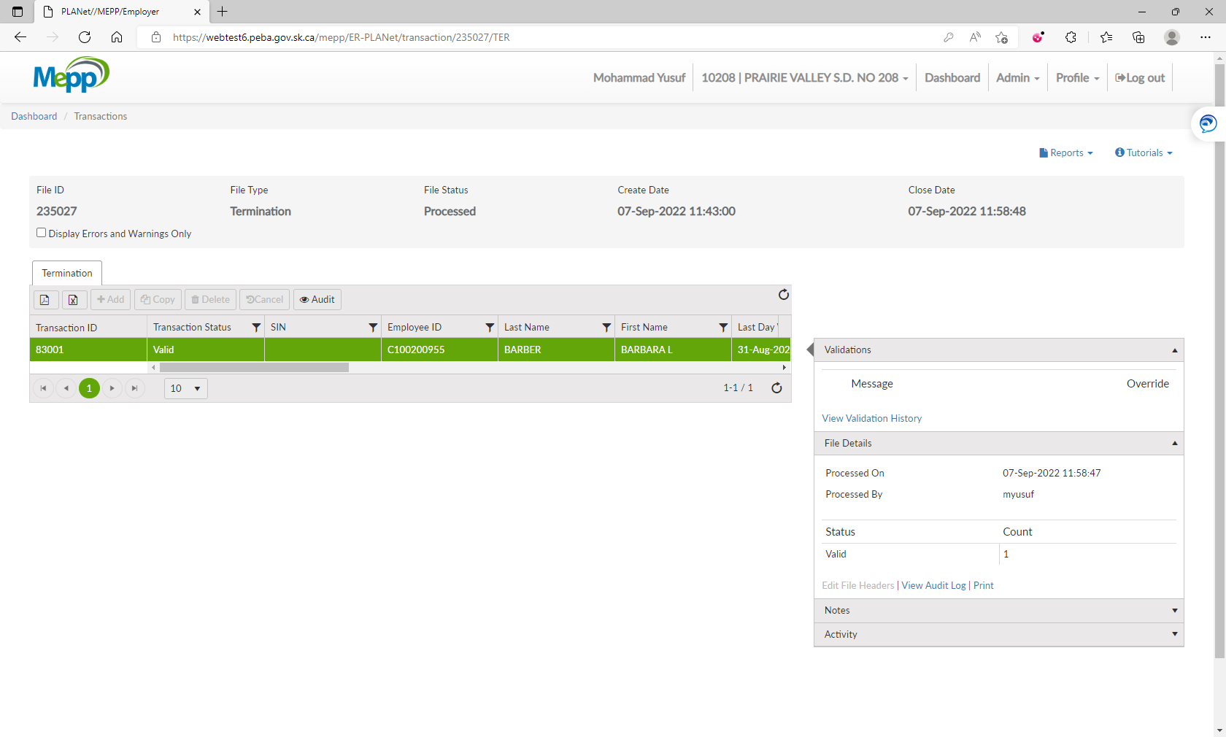

1. Go to Penfax -> Data Posting Batch -> Search by Batch Type and Employer.

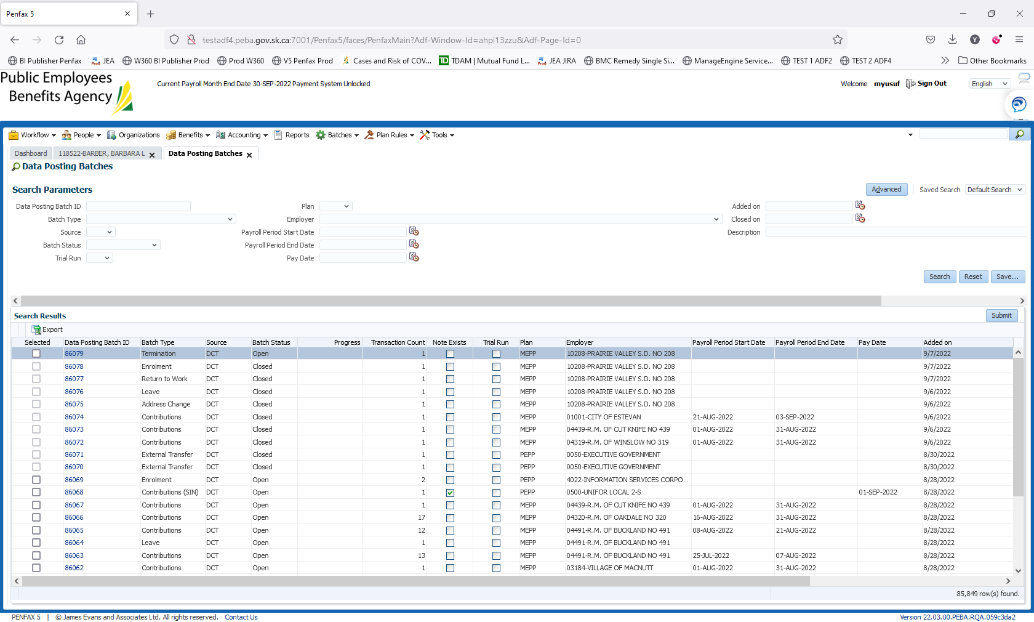

1. Open a batch you just processed through DCT. Go to Pending tab.

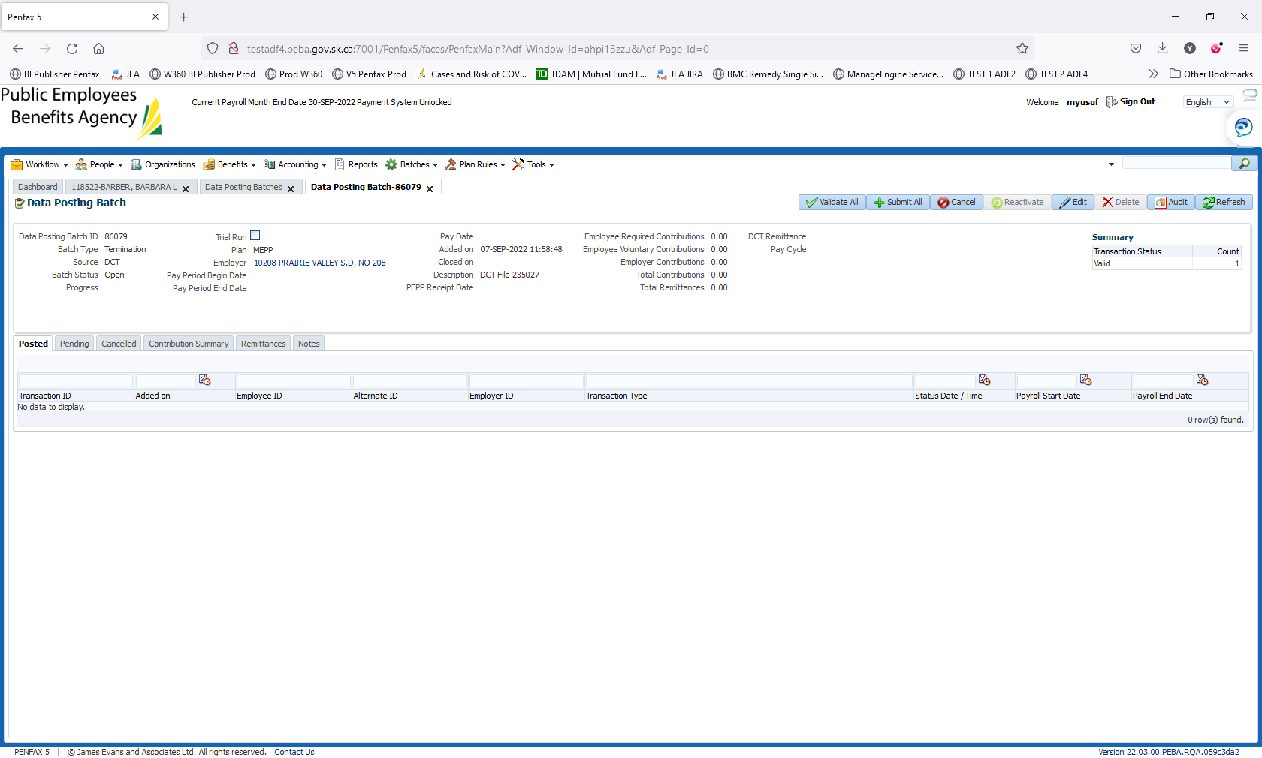

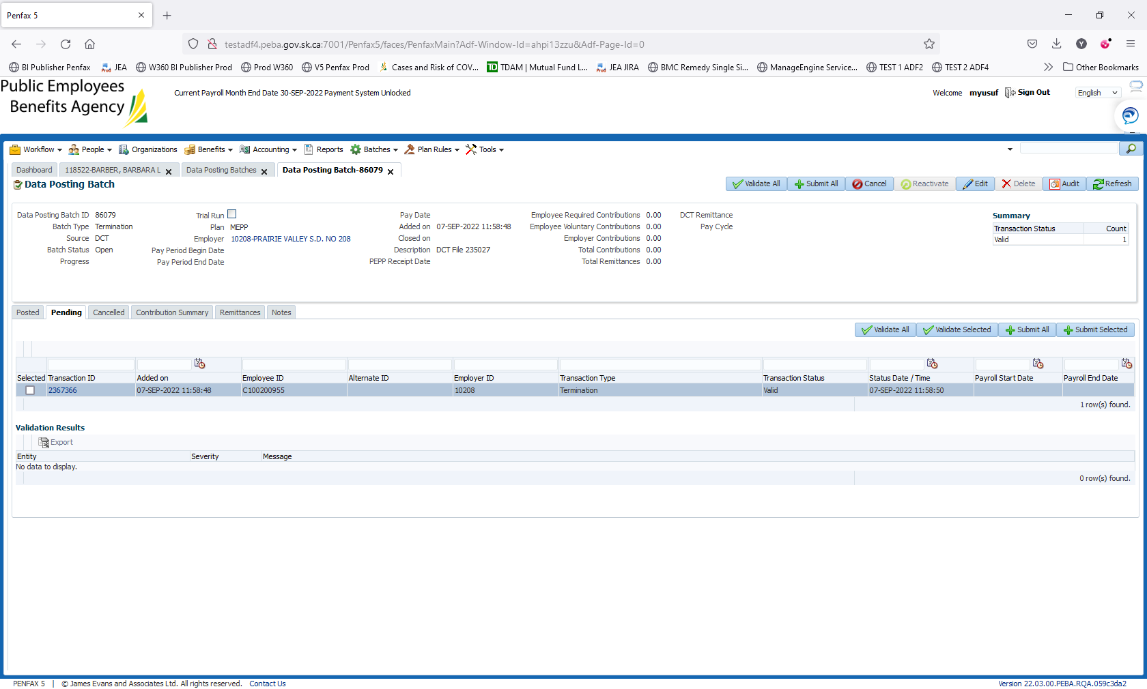

1. Click on Validate All and then Submit All.

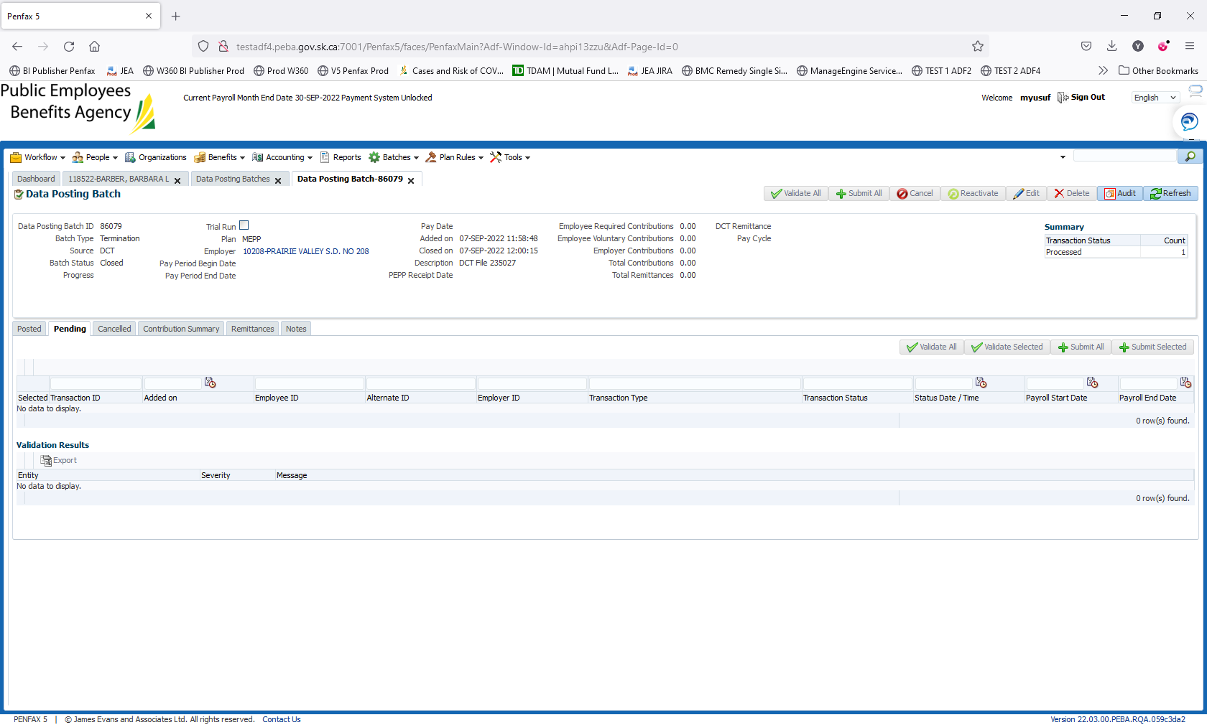

1. Batch is submitted/processed. Transaction is moved to Posted tab. Batch Status is now Closed.



1. Bring up a member again to see the termination.

